We continued from our last exercise of decision tree and applied bagging algorithm.

Setting up Bagging Classifier

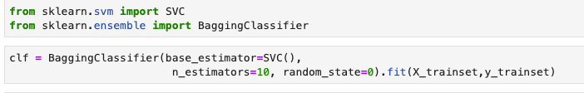

Prediction:

We want to predict Agent type = Present or Absent.

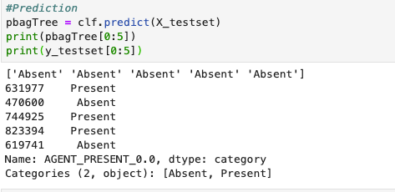

Evaluation:

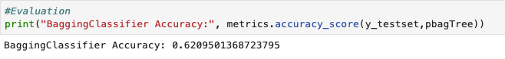

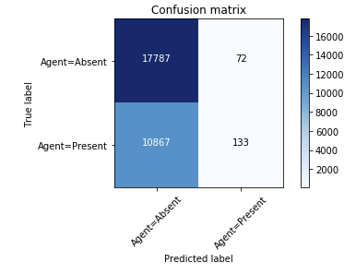

**Random Forest:**

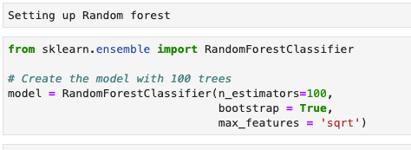

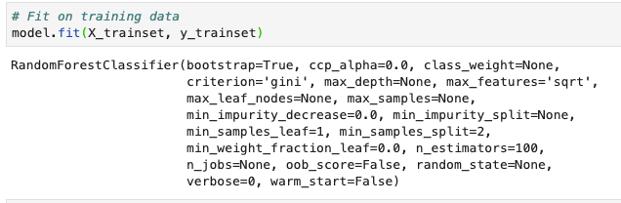

Prediction:

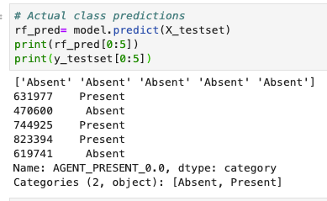

Evaluation:

